Dear ECHSA Members and friends,

As you know, our Annual ECHSA Meeting was organized jointly with the WSPCHS and took place in Sofia, Bulgaria from 20-22 June 2019, hosted by Stojan Lazarov and Christo Tchervenkov.

As those of you who were there (the majority of ECHSA Members) already know, the Meeting was a great success! The Scientific Program was rich with invited lectures from world-acclaimed expert colleagues from both ECHSA and the WSPCHS, with official participation of AEPC cardiologists, the Japanese Society for Pediatric Cardiology and Cardiac Surgery, and renowned colleagues from China. Our traditional sessions with surgical videos, best-worst case presentations, and peer reviewed oral and poster presentations were also included. In addition, there were presentations of great progress in database research, as well as in our multi-institutional studies, with several having already been presented at international meetings or published in major journals. Scientific Program highlights included the WSPCHS and ECHSA Presidential Lectures, a Postgraduate Course on the Management of the Critically Ill Neonate with Congenital Heart Disease, and a unique hands-on Surgical Simulation Workshop on the Arterial Switch Operation, where participants had the opportunity to perform the ASO on accurate 3D-printed heart Models under the guidance of expert surgeon colleagues!
Presentations and Abstracts of the Meeting can be found on our website (Members’ login required).

In the Business Meeting, important changes were voted in the ECHSA Membership Rules, in the direction of further democratization of our Association reaching out too the entire community of Congenital Heart Surgeons: Junior membership is now reserved to trainees in pediatric cardiac surgery. All congenital surgeons who are fully trained (according to the rules in the country where they practice now) are eligible for Full Membership. Accordingly, all current Junior Members are converted to Full Membership. Several new Members (all full members) were voted, and we welcome them to our Association!

At the leadership level, Rudolf Mair and Jürgen Hörer were voted as new Board Members.

James St. Louis, Research Chair of the World Society, was welcomed as a new Member of the Research Committee. Attilio Lotto joined the Database Committee.

The Social Program, organized by our local hosts Christo Tchervenkov and Stojan Lazarov was memorable, and the atmosphere extremely friendly and relaxed!

Finally, I would like to remind all that our 2020 Annual meeting will be held in Boston in Fall 2020, jointly with the CHSS, whereas an exciting Special Meeting will be organized by Prof. Bohdan Maruszewski in Warsaw in June 2020!

I encourage you to go over the ECHSA website Meetings Archive for more information on this historic meeting and on future planned ECHSA events.

Finally, please anticipate the upcoming new issue of the ECHSA Newsletter, as well as a new ECHSA Congenital Database Newsletter, which will celebrate the 20th anniversary of our Database!

I wish you all a great summer,

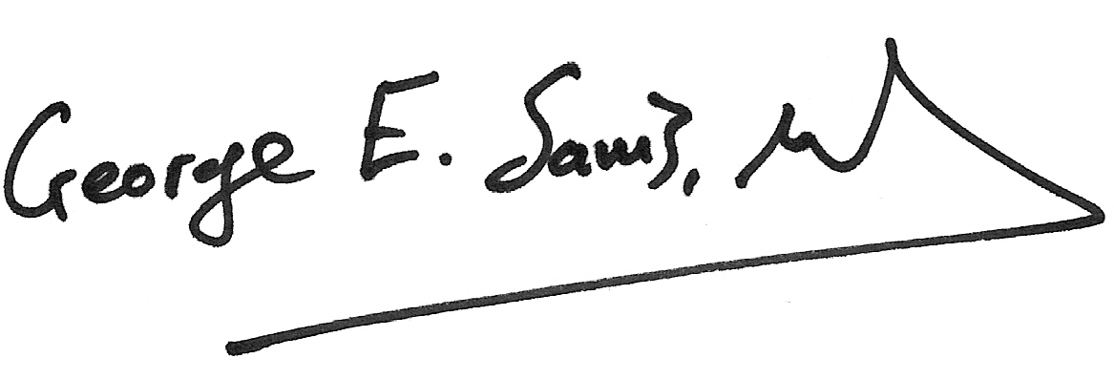
George Sarris
ECHSA President

